Alberta Beekeepers Commission
Project Proposal Submission Form
Thank you for considering Alberta Beekeepers Commission (ABC) in your request for research/project support.
Our Vision: We envision a vibrant, healthy, and growing Alberta beekeeping industry. We will achieve this through: Innovation, Education, Collaboration, and Research.
Our Mission: To develop and implement initiatives, and provide tools supporting Alberta Beekeepers, which improve the health of honeybee colonies, promote the quality of our products and services, and expand partnerships, markets, and opportunities.

Project name :
Date:
Contact details of person submitting application:
(Name, email, phone)
Please provide a brief description/summary of the project.
Please describe the following:
- Overview
- Objective
- What is the problem you are trying to solve?
- Methodology
- Project outcome
What is the timeline of the project?
Who is the principal investigator and collaborators of the project?
How much funding are you requesting from the ABC?
($ dollar amount)
Does the project have other funding sources? If yes, who?
Project Budget
Please provide a detailed description of the project budget and be sure to provide specifics regarding supplies, personnel, travel, equipment, etc.
Indicate confirmed funding from other sources and the project expenses that funding will cover.
*Overhead: The ABC will allow up to 15% overhead in project budgets. The budget must show the overhead.
Briefly describe how your project supports the research objectives of the ABC. (www.albertabeekeepers.ca/about/)
Will any Intellectual Property result from this project?
Please provide a brief bio of how your expertise supports your ability to complete this project.

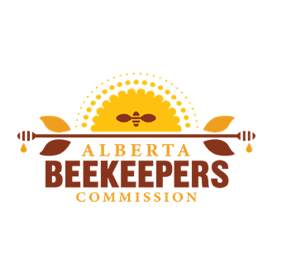
Please send all completed application forms including any supporting documentation to:

Attention: ABC Research Committee
Connie.phillips@albertabeekeepers.ca

