XXX Honey Farm Safety Plan

Contents

Farm Maps 3
Emergency Equipment Location 4
Personal Protective Equipment 5
Alcohol and Drug Policy 6
Harassment and Violence Policy 7
SDS Data Sheets 8
Standard Operating Procedures 9
Safe Lifting Procedures 9
Truck Loading Procedure 10
On Site Hazard Assessments 11
Documentation 18
Farm Incident Investigation Report – Including near misses. 18
Year End Safety Summary 22
Monthly Fire Extinguisher Inspection Sheet 23
First Aid Kit Checklist 24

Farm Maps

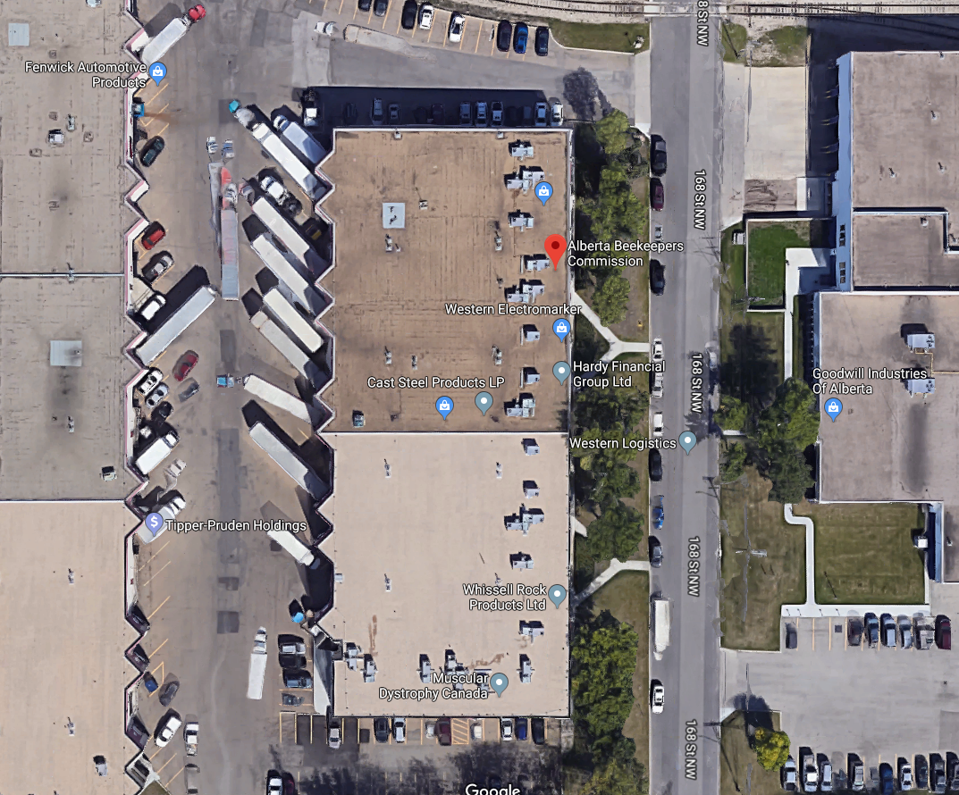
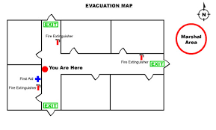

Emergency Equipment Location

Fire Extinguishers:
- One in each truck
- One in xxx room
- One in xxx room
First Aid Kits:
- One in each truck
- One in main office
Eye Wash Station:
- In extraction room
Epipens:
- In First aid kit located in office

Please review, familiarize yourself and sign the Emergency Response Plan.

Personal Protective Equipment

XXX Honey Farm requires proper appropriate Personal Protective Equipment to be worn at all times.

Employees are encouraged to review manufacturers’ instructions. Management remains available to answer any questions.
- Steel toe shoes must be worn at all times.
- Eyewear should be worn when building boxes/frames or during any task where an object could land in an employees’ eye.
- Proper hearing protection should be worn when undertaking loud tasks such has extracting honey.
- Rubber chemical gloves should be worn anytime an employee is handling chemicals
- Bee suit should be worn any time an employee is exposed to potential bee stings.
- Hard hats should be worn anywhere where there are overhead hazards, or signage in place.
- Appropriate breathing protection should be used according to the task performed.

PPE should be inspected periodically and each time before use. Employees should not use PPE that appears to be damaged. If, for any reason, a piece of PPE is deemed ineffective or damaged, it should be tagged “out of service” or discarded.

Alcohol and Drug Policy

A strong commitment exists to ensure all people are provided with a safe, healthy and reliable workplace. The use of illicit drugs, the inappropriate use of alcohol, prescription and non-prescription drugs can have serious adverse effects on a person’s health, safety and job performance. Working while under the influence of alcohol or illicit drugs will lead to injury or worse and is not allowed for the safety of others, our animals and our overall Operation.
The objective of the following work rule is to reduce the risk of incidents (safety, health, environmental and operational) of which alcohol and drug use may be a contributing factor or cause.
• No worker shall consume, possess or distribute alcohol or illegal drugs on any farm workplace
• No worker shall report to work unfit for duty or be at work under the influence of alcohol or drugs that may or will affect their ability to work safely
• No worker shall misuse prescription or non-prescription drugs while at work. If a worker is taking a prescription or non-prescription drug for which there is a potential unsafe side effect, he or she has an obligation to report it to the supervisor.
Possession or use on the job of unauthorized drugs or alcohol and or reporting for work while under the influence of either is strictly forbidden and constitutes grounds for dismissal
Signature Date

Harassment and Violence Policy

We believe in the safety of our workers, clients and visitors to our farm.
Individuals should feel safe and free to express themselves while in their workplace environment.
Violence, harassment, bullying and physical fighting will NOT be tolerated at any level.
Every individual shall be shown respect regardless of their gender, race and religion.
All harassment complaints will be investigated by management and dealt with on an individual basis. If the matter cannot be resolved with the resources the farm has to offer, proper authorities and agencies may be called upon to resolve pending discriminatory issues and complaints.

Signature Date

SDS Data Sheets

SDS Data Sheets can be found in the binder located in XXXX.
It is important that all employees familiarize themselves with the WHMIS pictograms and refer to the SDS Data sheets before handling any chemicals.

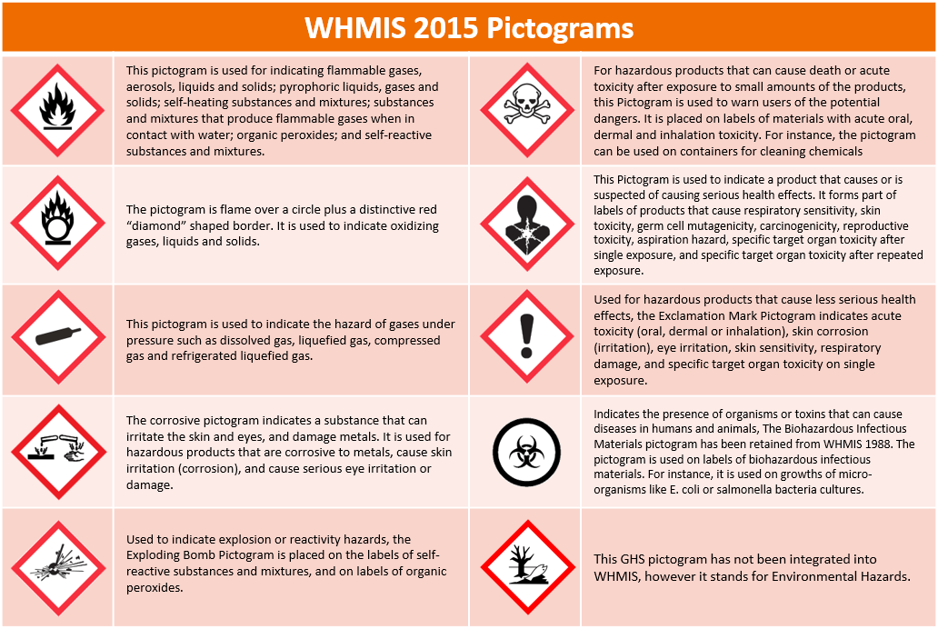

Standard Operating Procedures

Safe Lifting Procedures

Daily operations require a lot of heavy lifting, whether it is while pulling honey or moving equipment which can lead to back injuries and put a worker out of commission for an extended period of time.
Employees, as well as managers should familiarize themselves with proper lifting techniques to lessen probabilities of injuries often leading to lost time. Ensure to include safe lifting procedures in your orientation guide when hiring new employees. It is also good to refresh existing staffs’ memories periodically.
- Your feet should be shoulder-width apart.
- Squat down, bending at the hips and knees only. Put one knee down to the floor if needed and your other knee in front of you, bent at a right angle.
- Keep good posture. Look straight ahead, and keep your back straight, your chest out, and your shoulders back. This helps keep your upper back straight while having a slight arch in your lower back. Never bend forward to pick something up.
- Lift Slowly by straightening your hips and knees. Keep your back straight, and don't twist as you lift.
- Hold the load as close to your body as possible, at the level of your belly. Never lift above shoulder level.
- Use your feet to change direction, taking small steps.
- Lead with your hips as you change direction. Keep your shoulders in line with your hips as you move to avoid any twisting.
- Put your load down carefully, squatting with the knees and hips only.

Confined Spaces

Employees are not to enter any confined space without notifying management. Confined space are any areas that have an abnormal entry/exit point or areas that were not designed for humans to enter and/or occupy. Confined spaces can also be defined by areas that have limited and/or no ventilation at all.
Employees should always be wearing hard hats while in confined spaces.
When cleaning the honey tank, employees should always work by pairs. While one is inside, another should be outside, communicating and monitoring the employee cleaning the inside of the tank.
Step 1
Step 2
Step 3
Step 4

Vehicles

Maintenance on vehicles is to be done and recorded in the xxx binder.
Vehicles are to be cleaned weekly and should be visually inspected every day before using them.
All vehicles are equipped with a fire extinguisher and first aid kit. If one of them is missing one of the items, please report it to management as soon as possible.
When approaching a Bee yard on a highway, employees should place traffic cones in front and back of the vehicle.
If vehicle is stuck in a bee yard, please contact management before attempting to tow it out. Always use approved appropriate equipment.

Forklift

Staff should always visually inspect forklifts before use.
Manufacturer’s specifications should always be followed, and max capacity NEVER exceeded.
Only trained employees that are comfortable with the use of the forklift should operate it.
Operator should only carry one pallet at a time.

Stacking procedures

Drums
At XXX Farms we never stack out drums higher than (number) high. Drums should be moved and stacked using the forklift. Drums should sit up right/laying down.

Boxes
Boxes are staked 6 high on pallet for a total of 36. Proper lifting procedure should be used when staking boxes.
Pallets of boxes should be staked 3 high

Containers
Containers should be staked no higher than 3 on top of each other.

Truck Loading Procedure

Always be aware of your surroundings while loading trucks.

- Ensure truck is parked in a suitable position with room to manoeuvre forklifts on both sides.
- When moving multiple pallets with the forklift, first place them near the truck and then load one pallet at a time. Never load a double pallet directly onto truck.
- Ensure that all coworkers in the area are wearing hardhats and are aware.
- When climbing onto a truck/load always use three points of contact.
- Ensure loads are properly secured using batter boards, and straps. Only use ropes for secondary securement.
- Never throw straps with the handle first, secure hook and then unroll strap.
- Ensure truck wash stations are ready to use every day.
- Ensure all storage boxes are securely closed
- Drivers must complete walk around inspection prior to leaving.

On Site Hazard Assessments

Hazard assessments should be redone periodically, allowing to update them if needed as well as refresh employee’s memories to potential hazards.
Hazard assessments are generally similar but can be different depending on the different bee yard set ups you operate out of.

Engineering controls are designs or modifications to plants, equipment, ventilation systems, and processes that reduce the source of exposure.
Administrative Controls are controls that alter the way the work is done, including timing of work, policies and other rules, and work practices such as SOPs (including training, housekeeping, equipment maintenance, and personal hygiene practices.)
Personal Protective Equipment are equipment worn by individuals to reduce exposure such as contact with chemicals or exposure to noise.

Job Description: honey extraction
Job Tasks: lifting honey boxes, removing frames, using extractor, refilling boxes with spun frames
Date Updated:
FORMAL HAZARD ASSESSMENT
Job Hazard |  | Hazard Controls (Engineered (E), Administrative (A), PPE (P)
1 | Heavy lifting  Back injury | Engineered Control  Use lifts, forklift, drum lift attachment on forklift.  Administrative Control  Bend at the knees, Safe lifting procedures (SOP) avoid lifting and twisting, get help lifting something heavy or awkward in size and shape  PPE Tight fitting leather gloves or gloves with rubber grip
2 | Musculoskeletal injuries | Engineered Control  Adjust height of worker to extractor via floor adjustable platforms  Administrative Control  Rotate workers through different parts of the line, proper ergonomics, fit height and strength of employee to job task  PPE Back support belt
3 | Moving parts,  Entanglement | Engineered Control  Automatic shut off, guards, protective shields  Administrative Control  Safe operating procedures, first aid kit, stickers /signs in areas of rotating parts, first aid kit, Emergency Response Plan (ERP)  PPE Short sleeves
4 | Pinch points chain conveyer | Engineered Control  Automatic shut off, guards  Administrative Control  Stickers indicating pinch points, first aid kit, ERP  PPE Short sleeved shirts
5 | Noise | Engineered Control  Modified/upgraded noise reduction equipment  Administrative Control  Hearing protection protocol in areas with 85 decibels or higher, minimize/control time exposure to noisy environment  PPE Hearing protection-earplugs, ear muffs
6 | Biological hazards  Bee stings | Engineered Control  Administrative Control quickly remove bee stings, epipens, Benadryl, first aid kits, ERP  PPE coveralls, veil, gloves
7 | Slippery floor | Engineered Control  Functional drainage. Sufficient amount.  Administrative Control  Keep floor clean (water and honey very slippery), floor to be kept dry with use of squeegee, gritted floor  PPE Good rubber boots with good traction
8 | Dehydration | Engineered Control  Fans to circulate air  Administrative Control  Follow safe working procedures, train on signs and symptoms of heat exposure, take breaks, drink plenty of fluids, electrolyte replenisher at the end of a shift, First aid kit,  PPE cool clothing, short sleeves

Job Description: Chemical Use
Job Tasks: Mixing chemicals, application, cleanup, and storage
Date Updated:
FORMAL HAZARD ASSESSMENT
Job Hazard |  | Hazard Controls (Engineered (E), Administrative (A), PPE (P)
1 | Preparing chemicals | Engineered Control  Ventilation fans  Administrative Control  Always follow label instructions. Never mix chemicals alone  PPE Respirator, Chemical resistant gloves, full face shield, coverall
2 | Chemical spill | Engineered Control  Ventilation fans,  Administrative Control  Always mix chemicals in or near the Chem shed where eye wash station is located.  PPE Respirator, Chemical resistant gloves, full face shield, coverall
3 | Exposure | Engineered Control  Use premixed chemicals as much as possible.  Administrative Control  Follow label for proper application methods,  PPE Respirator, Chemical resistant gloves, full face shield, coverall
4 | Disposal | Engineered Control  Keep chemicals in chem shed. Use funnels as big as possible.  Administrative Control  Follow label for proper disposal of chemical products and containers  PPE Respirator, Chemical resistant gloves, full face shield, coverall

Job Description: forklift operation
Job Tasks: Driving/ operating, lifting loads, stacking,
Date Updated:
FORMAL HAZARD ASSESSMENT
Job Hazard |  | Hazard Controls (Engineered (E), Administrative (A), PPE (P)
1 | collision with people/workers | Engineered Control  Back up beeper, flashing lights, maintain good traction, barricades  Administrative Control  Signage, lighting, use a spotter, forklift operator training and competency, establish eye contact, no movement if you lose sight of worker, remove nonessential personnel, establish travel lanes, complete pre-use inspection prior to starting work. Do repairs as required prior to work. Ensure windows are clear, communication with other workers about forklift activity and planned route, no passengers, one seat one rider, use seatbelt  keep non-essential workers/family/animals away from work area, alert and competent operator, control access and shut down work when others are in work area, do not disable safety devices  PPE Hi visibility vests for other workers, steel toes boots, safety glasses
2 | collision with equipment, standing structures, pinch points, | Engineered Control  Back up beeper, flashing lights, maintain good traction, lighting,  Administrative Control  Use a spotter forklift operator training and competency, establish travel lanes and rights of way, mark protrusions, mark collision points, minimize interaction with other equipment  PPE Steel toed boots, safety glasses, high visibility vest
3 | Exhaust fumes, fuel exposure | Engineered Control  Only use propane forklift in building unless necessary, ventilation  Administrative Control  Limit operating time of equipment in closed areas  Use well ventilated area to fuel or work on equipment.  PPE Steel toed, boots safety glasses, gloves
4 | noise | Engineered Control  Give priority to quietest equipment available.  Administrative Control  Limit exposure time to loud environment >85db  PPE Ear plug or ear muffs
5 | Mounting and dismounting | Engineered Control  Use handrail  Administrative Control  Enter cab using 3-point contact, when parking, place forks flat on the ground, engage the park brake  PPE Steel toed boots, safety glasses, gloves
6 | Rollover, tipping | Engineered Control  Ensure rollover protection is intact  Administrative Control  Training, safety belt, do not overload forklift, reference load plate for allowable lifting capacity, keep load low while driving, no riders, avoid steep slopes, travel up and down slopes not across, avoid sharp turns and slopes with a raised load, load and unload on level ground, do not leave forklift with engine running or with lift arm up, clear driving compartment of loose items.  PPE Steel toed, boots safety glasses, gloves
7 | Caught in equipment, crush | Engineered Control:  Equipment guards, locking devices on forks  Administrative Control:  Procedures – lower forks, lockout while working on the machine, engage parking brake, shut down engine, remove key, ERP, first aid kit, rescue plan  PPE leather gloves
8 | Fire and/or explosion | Engineered Control:  Safety switches  Administrative Control:  Fueling procedures, shut off engine for fueling, fire extinguisher readily available, no smoking while refueling, no source of ignition while refueling, refuel in ventilated area, don’t disable safety switches, focus on job and avoid distractions while fueling, ERP. Fire extinguisher, first aid kit  PPE safety gloves
9 | Working alone- | Engineered Control:  Cage on forklifts.  Administrative Control:  Communication program/system, cell phone or radio with coverage, working alone policy.  PPE: Steel toes. Hard hat
10 | Lacerations, abrasions, pinch points, burns | Engineered Control:  Equipment guarding,  Administrative Control:  Training on equipment, do not disable safety switches, clear driving compartment of loose items, pinch point safety stickers, ERP, first aid kits  PPE: Leather gloves
11 | Electrical hazards, overhead lines | Engineered Control:  Electrical breakers. Instal lines underground. Door on electrical panel.  Administrative Control:  Inspect area for overhead hazards and overhead powerlines, ERP, electrical safety training, first aid training. Instal signage/labeling about overhead electrical hazard.  PPE: Gloves
12 | Equipment failure | Administrative Control:  Pre-use equipment inspection (walk around), training on equipment use, lock out tag out (LOTO) damaged equipment
13 | Inexperienced operator | Administrative Control:  Train new operators (standards in operating manual), assess competency  PPE: Steel toed boots, gloves, eye protection, hearing protection, coveralls
14 | Health Hazard: Exposure to hydraulic oil or fuel  Splashing, spraying or injection of hydraulic fluid | Engineered Control:  Safety devices  Administrative Control:  Inspect for leaks or cracks in lines regularly LOTO, eye wash bottle, first aid kit, ERP  Refuel or work on machine in ventilated area, inspect equipment regularly for leaks and cracks, do not disable safety devices.  PPE: Safety glasses, coveralls, gloves, boots

Job Description: Warehouse storage
Job Tasks: Loading trucks, Barrel storage, Checking sugar and honey tanks
Date Updated:
FORMAL HAZARD ASSESSMENT
Job Hazard |  | Hazard Controls (Engineered (E), Administrative (A), PPE (P)
1 | Falling | Engineered Control  Cages around ladders on honey tank or sugar water.  Administrative Control  Always use three points of contact when climbing, never work alone in an elevated position.  PPE Steel toed work boots with proper grip. Harness and tie off when working above 3 meters.
2 | Pinch | Engineered Control  Administrative Control  Load according to proper loading procedure.  PPE steel toe boots, gloves.
3 | Exposure | Engineered Control  Administrative Control  Follow label for proper application methods,  PPE Respirator, Chemical resistant gloves, full face shield, coverall
4 | Disposal | Engineered Control  Administrative Control  Follow label for proper disposal of chemical products and containers  PPE Respirator, Chemical resistant gloves, full face shield, coverall

Job Description: Bee yard, Getting the nucs
Job Tasks: Tipping boxes, blowing bees out, loading trucks
Date Updated:
FORMAL HAZARD ASSESSMENT
Job Hazard |  | Hazard Controls (Engineered (E), Administrative (A), PPE (P)
1 | Wildlife attack | Engineered Control  Electric fences  Administrative Control  Ensure to have good look before exiting the vehicles.  PPE Bear Spray
2 | Hummer Bee tipping.  Injuries/Damaging equipment | Engineered Control  Administrative Control  Go over bee yard thoroughly for potholes and other hazards before bringing equipment in  PPE steel toe boots, gloves.
3 | Back injuries from lifting | Engineered Control  Use Equipment as much as possible  Administrative Control  Proper lifting procedure  PPE  Back support belt
4 | Bee stings | Engineered Control  Administrative Control  Try to avoid use of colognes, shampoos and any other bee-attracting scents.  PPE Bee suit

Documentation

Farm Incident Investigation Report – Including near misses.

All incidents including near misses must be reported to management and the following report must be filled in a timely manner. The sheets can be found in XXXXX.

Incident or Occupational Illness Details:

Date & Time of Incident/Illness: |  | Incident Location:
Date & Time Reported: |  | Reported to Whom:
Report Completed By: |  | Employee(s) Involved in Investigation: (include witnesses:  Name
Name of person involved directly:

Incident resulting from
☐ Farm ☐ Field ☐ Other
Hours worked prior to incident: | Incident resulting from  ☐ Farm ☐ Field ☐ Other | Loss / Damage Occurred to:  ☐ Person ☐ Facility ☐ Equipment ☐ All

Classification of Loss:

☐ NEAR MISS INCIDENT  ☐ INJURY  ☐ PROPERTY DAMAGE  ☐ SPILL / RELEASE | ☐ Unsafe Act ☐ Unsafe Condition ☐ Both  ☐ First Aid ☐ Medical Aid ☐ Restricted Work ☐ Lost Time ☐Illness ☐ Fatality  ☐ Design ☐ Misuse ☐ Did not follow Procedure ☐ Natural ☐ Theft / Vandalism  ☐ Maintenance ☐ Fire ☐ Explosion ☐ Equipment Failure ☐ Other: _________________  ☐ Human Error ☐ Equipment failure ☐ Procedure ☐ Maintenance issue

Outside Personnel Contacted (Fire Department, Emergency, etc.)
Name |  | Contact Number | Date / Time Contacted
Sequence of Events
Date | Time | Description | Source
Drawing (attach photos)

6. Indirect Causes: What failures to act/or conditions caused the event
 | Congested or Restricted Workspace |  |  | Using Defective or Unsafe Equipment |  | Driving Errors
 | Drug/Alcohol Influence |  |  | Environmental Conditions (Smoke, Fumes, Dust) |  | Equipment Operator Error
 | Failure to Follow Rules |  |  | Failure to Follow Safe Work Procedures |  | Failure to Get Assistance
 | Failure to Secure |  |  | Failure to Tag out/Lock out |  | Failure to Use Appropriate PPE
 | Failure to Warn or Instruct |  |  | Fire/Explosion Hazard |  | Horseplay or Fighting
 | Improper Guards or Barriers |  |  | Improper Labeling |  | Improper Lifting, Pushing or Pulling
 | Improper Loading or Stacking |  |  | Improper Placement or Storage |  | Noise
 | Improper PPE |  |  | Improper Use of Equipment or Tools |  | Mobile Radio/Cell Phone Use
 | Inadequate Warning System |  |  | Inadequate/Excessive Lighting |  | Wearing Inappropriate Clothing
 | New or Modified Equipment |  |  | Uneven Ground Conditions |  | Removing or Bypassing Safety Device
 | Operating at Unsafe Speed |  |  | New or Modified Procedure |  | Servicing Equipment in Operation
 | Poor Housekeeping |  |  | Proper Tools or Equipment not Available |  | ZZ - Other (Add Notes)
Basic Causes (related to the circumstances that allowed the incident to occur. Ask why the indirect conditions existed.)

 | Abuse or Misuse |  |  | Equipment Wear and Tear |  | Physical Stress or Fatigue
 | Inadequate Inspections |  |  | Inadequate Maintenance |  | Lack of Skill
 | Inadequate Mental Capability |  |  | Inadequate Work Standards or Procedures |  | Inadequate Physical Capability
 | Inadequate Tools, Equipment or Materials |  |  | Mental Stress or Fatigue |  | Inadequate Supervision or Leadership
 | Lack of Training or Knowledge |  |  | ZZ - Other (Add Notes) |  | ZZ - Other (Add Notes)
Root Cause (where the system failed) |  |  | Comment
Inadequate standards
Inadequate compliance with the standards
Inadequate systems
Other:

8. Corrective Actions: Describe Actions Taken and Follow up that will be Taken to Prevent Reoccurrence. Include dates for implementation with corrective actions.

Action: | Person assigned | Date completed
Action: | Person assigned | Date completed
Action | Person assigned | Date completed
Action | Person assigned | Date completed

9. Reporting & Investigation Stage: 10. Investigation Completion Signing Off:

Tracking Information |  | Person completing investigation: | Date:_______________
Update | Date: | Review with all Farm Workers: | Date:
Final Reporting | Date: | Farm Manager Final Review: | Date:

Year End Safety Summary

Date: ______________________________________
1. Total Number Workers Hired __________________________________
Total Number Completed Orientations __________________________________
2. Total Number Area Team Meetings __________________________________
Total Number of Safety Meetings __________________________________
Total Number of Safety Committee Meetings __________________________________
3. Total Number Monthly Inspections Completed __________________________________
Total Unsafe Acts/Conditions Identified __________________________________
Total Number Corrected __________________________________
4. Total Number of Accidents/Incidents/Illnesses __________________________________
Damage Only __________________________________
Injury Only __________________________________
Injury and Damage __________________________________
Lost Time Injury __________________________________
Days Lost __________________________________
Medical Referrals __________________________________
Near Miss __________________________________
5. Total Number of Investigations Completed __________________________________
Outstanding __________________________________
Total Number of Recommendations Made __________________________________
Outstanding __________________________________
_______________________________________
Safety Coordinator

Monthly Fire Extinguisher Inspection Sheet

Location | Date | Notes | Initials

Fire Extinguishers should be checked monthly and inspected yearly

First Aid Kit Checklist

Item | Quantity | Expiry Date | Notes

First Aid kit should be checked monthly.
First Aid Kit should be clean, dust free.
Items should not be expired.
Kit must be visible and clearly marked for anyone to locate and use.
ALCOHOL AND DRUG POLICY

A strong commitment exists to ensure all people are provided with a safe, healthy and reliable workplace. The use of illicit drugs, the inappropriate use of alcohol, prescription and non-prescription drugs can have serious adverse effects on a person’s health, safety and job performance. Working while under the influence of alcohol or illicit drugs will lead to injury or worse and is not allowed for the safety of others, our animals and our overall Operation.
The objective of the following work rule is to reduce the risk of incidents (safety, health, environmental and operational) of which alcohol and drug use may be a contributing factor or cause.
• No worker shall consume, possess or distribute alcohol or illegal drugs on any farm workplace
• No worker shall report to work unfit for duty or be at work under the influence of alcohol or drugs that may or will affect their ability to work safely
• No worker shall misuse prescription or non-prescription drugs while at work. If a worker is taking a prescription or non-prescription drug for which there is a potential unsafe side effect, he or she has an obligation to report it to the supervisor.
Possession or use on the job of unauthorized drugs or alcohol and or reporting for work while under the influence of either is strictly forbidden and constitutes grounds for dismissal
Signature Date

Harassment and Violence Policy

We believe in the safety of our workers, clients and visitors to our farm.
Individuals should feel safe and free to express themselves while in their workplace environment.
Violence, harassment, bullying and physical fighting will NOT be tolerated at any level.
Every individual shall be shown respect regardless of their gender, race and religion.
All harassment complaints will be investigated by management and dealt with on an individual basis. If the matter cannot be resolved with the resources the farm has to offer, proper authorities and agencies may be called upon to resolve pending discriminatory issues and complaints.

Signature Date

